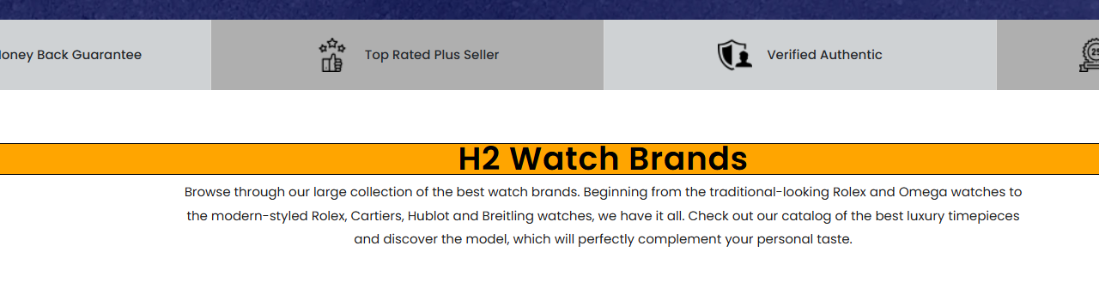
Certified Pre Owned luxury watch brands h1

Browse through our large collection of the best luxury watch brands. Beginning from the traditional-looking Rolex and Omega watches to the modern-styled Rolex, Cartiers, Hublot and Breitling watches, we have it all. Check out our catalog of the best luxury timepieces and discover the model that will perfectly complement your personal taste.

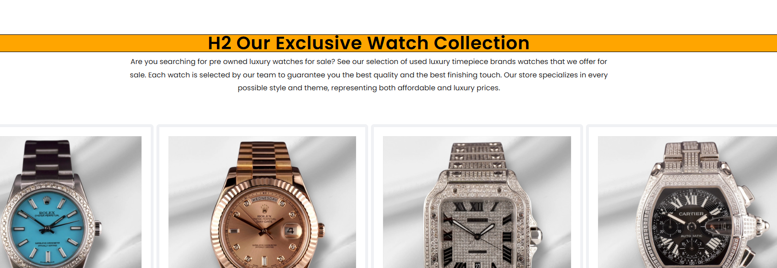

Our Exclusive Collection of the Best Luxury Watch h2
Are you searching for pre owned luxury watches for sale? See our collection of used luxury timepiece brands that we offer for sale. Each watch is selected by our team to guarantee you the best quality and the best finishing touch. Our store specializes in every possible style and theme, representing both affordable and luxury.

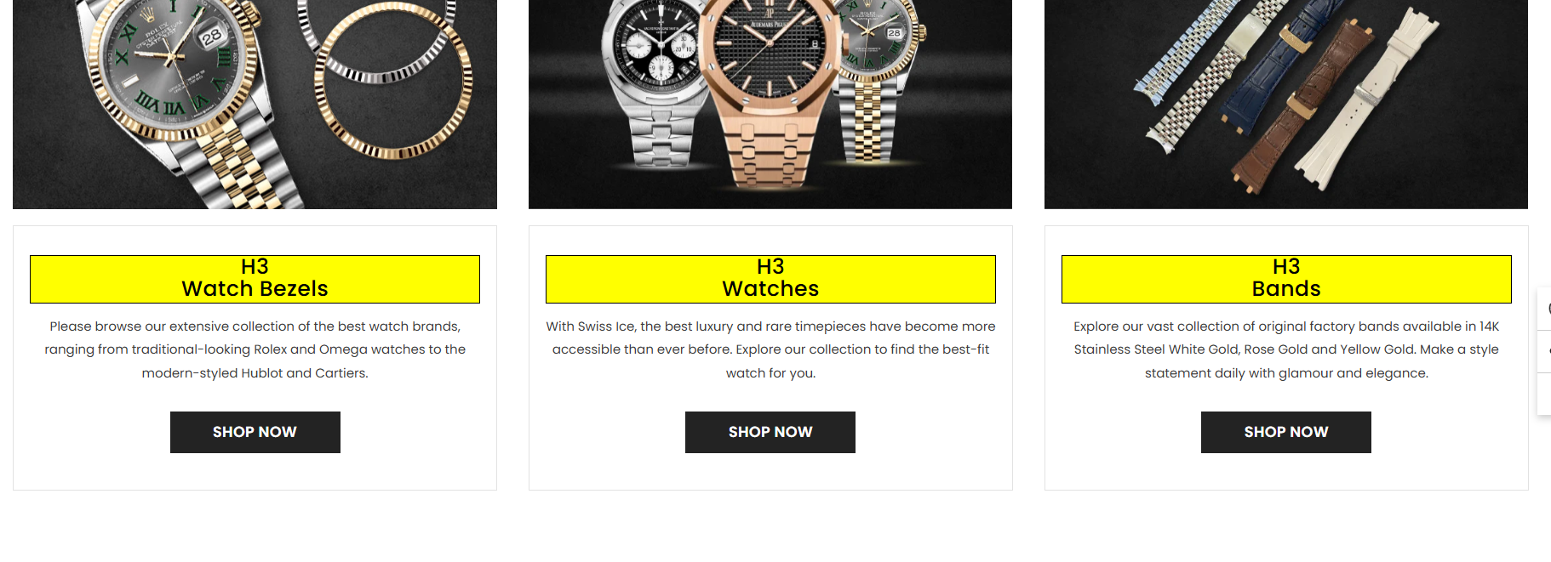
Watch Bazel
Explore Our Range of Luxury Watch Bezels. From Classic Rolex & Omega Styles to Bold Hublot & Cartier Designs.

